**Team Name:** pie9

|  |  |  |  |  |
| --- | --- | --- | --- | --- |
| Anthony Nguyen | George Stergiadis | Artem Potemkin | Victor Heather | Sahil Mann |
| Myers-Briggs Test | | | | |
| Mind: Introverted  Energy: Observant  Nature: Feeling  Tactics: Prospecting  Identity: | Mind: Introverted  Energy: Observant  Nature: Feeling  Tactics: Prospecting  Identity: Turbulent | Mind: Introverted  Energy: Observant  Nature: Feeling  Tactics: Prospecting  Identity: Turbulent | Mind: Extraverted  Energy: Intuitive  Nature: Feeling  Tactics: Judging  Identity: Turbulent | Logistician |
| Online Learning Style Test | | | | |
| Vark-Test | Learning Style Test | Learning Style Test | How to Study Results | Learning Style Test |
| Visual: 11  Aural: 12  Read/Write: 5  Kinaesthetic: 12 | Auditory: 25%  Visual: 50%  Tactile: 25% | Auditory: 40%  Visual: 30%  Tactile: 30% | Visual Learner | Tactile type of learner |
| Online test of our choosing | | | | |
| Leadership Style Test | Big Five Personality Test | Workplace Personality Test | 123test (Competency Test) | Enneagram Test |
| Transformative leader | Extroversion: 16%  Emotional stability: 22%  Agreeableness: 71%  Conscientiousness: 7%  Intellect/Imagination: 2% | Guardian | Noticing: 6  Taking the initiative: 5  Analysing: 6  Deciding: 6  Creating: 5  planning and organising: 6  Persevering: 6  Reacting flexibly: 7  Functioning under pressure: 6  Communicating verbally: 6  Communicating in writing: 5  Helping: 7  Networking: 5  Checking: 6  Leading: 6  Self-management & development: 7 | Individualist and a sceptic  Investigator trait |
| Personal results | | | | |
| ●Reserved and focuses more on himself  ●Tends to pursue goals without needing much external connection  ●Type to enjoy lending a hand and sharing experiences with others  ●Hands on type of learner and an aural learner  ●Learning through reading and/or writing is not his most ideal style of learning  ●Confidence to take bigger risks  ●Rarely needs to be the centre of attention | ●Relaxed and warm  ●Learn by reading or seeing pictures  ●Understand and remember things by sight  ●Difficulty with spoken directions  ●May be easily distracted by sounds | ●Open-minded  ●More rational rather than emotional  ●Mostly organised  ●Can easily get distracted  ●Gets anxious in unfamiliar situations  ●Easier to concentrate on new information if it’s read out to him | ●Visual learner who likes to help others and is social | ● Sharp and have a fact-based mind  ● Strong-willed, very responsible and calm, and practical  ● Stubborn, insensitive, always by the book, judgmental and that he often blames himself  ● Approach things in life could sometimes be more of a liability than an asset  ●If he can touches and moves about while he is trying to memorise and learn it will allow him to memorise things better.  ●Likes to seek out knowledge and understanding and is less comfortable around people |
| Working in group results | | | | |
| ●Willing to lend a hand and help others  ●Can be too reserved  ●Prefers to have group members walk him through the process when learning from others, rather than simply give material to read  ●If he tries too hard to look ahead, he may get lost and lose focus on the present | ●May exhaust themselves if their role requires an excessive amount of social interaction  ●Charming and has excellent networking skills  ●Can get stressed with large tasks, but can combat this with support of other team members | ●Likes to work independently on distributed work where he can, unless collaboration is required  ●Not afraid to speak up even if he is wrong | ●A team player and like to put the group’s best interest above all  ●Works in a team often, so it is a comfortable environment  ●Likes members who are prepared to put in the necessary time and effort needed to get the job done  ●Likes reliance on one another and compensate for the workload when required |  |

**Analysis**

|  |
| --- |
| Based on the test results, we have a few common traits. Some of us are more introverted than others, however everyone can work well in a group environment. In general, we all seem like a good bunch of people: friendly and not self-centred. A lot of our traits match in the Myers-Briggs Test, so it looks like we will get along as a group. Some of us do have difficulties doing large portions of work, can get distracted and lose focus, so supporting each other within our group and providing help will definitely help us to work as efficiently as we can. But we also shouldn’t forget that we all have our own ways of working and learning and should always keep that in mind. It seems like it would be best for us to distribute the work evenly amongst ourselves and work on our portions of work independently, checking over with each other during our meetings and providing feedback. |

**Anthony Nguyen**

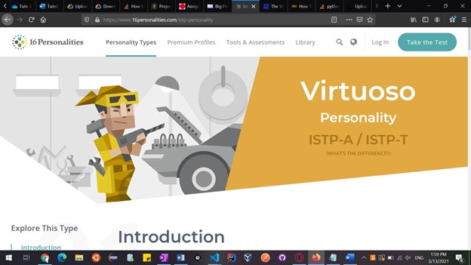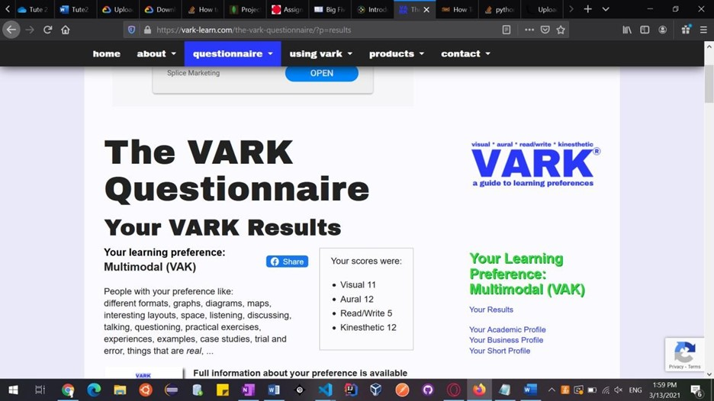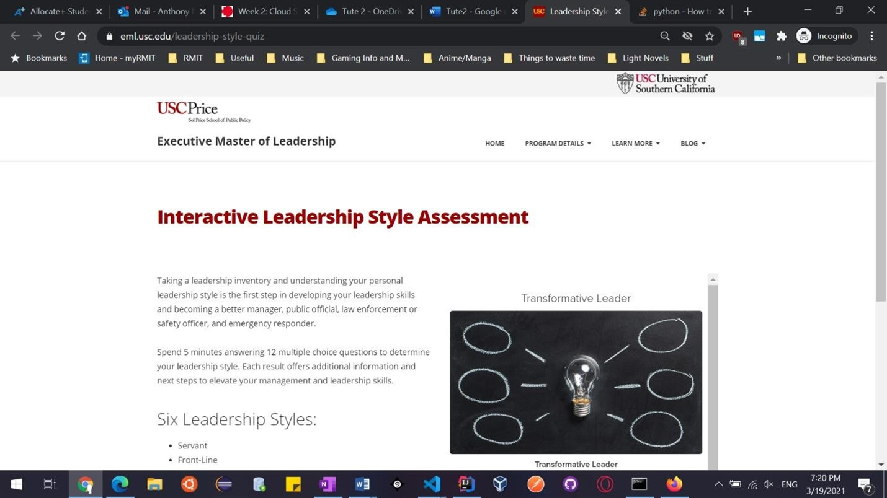

**George Stergiadis**

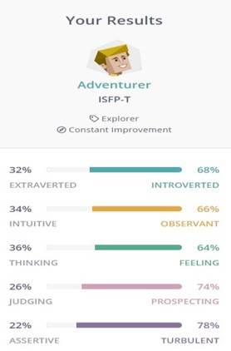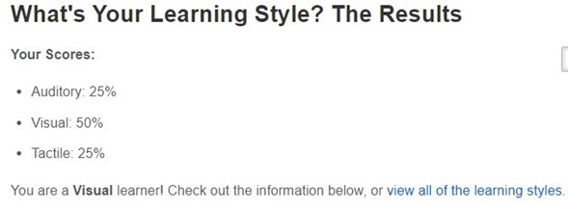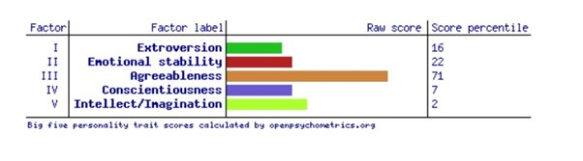

**Artem Potemkin**

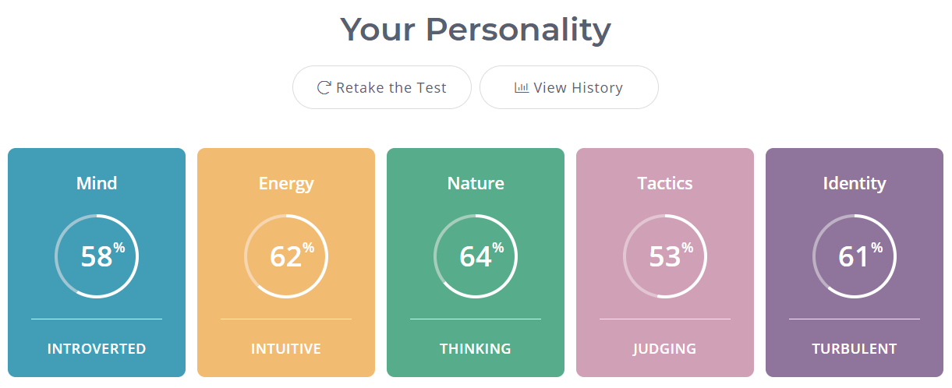

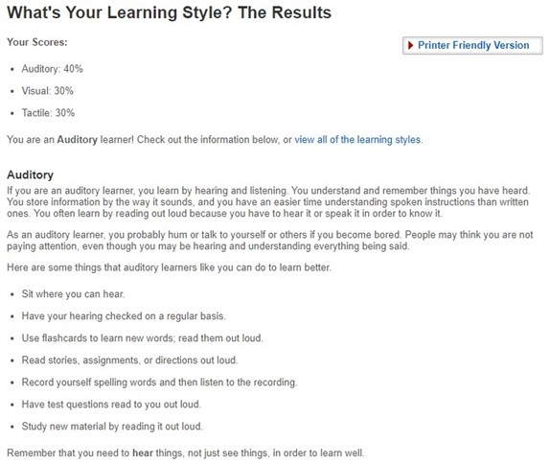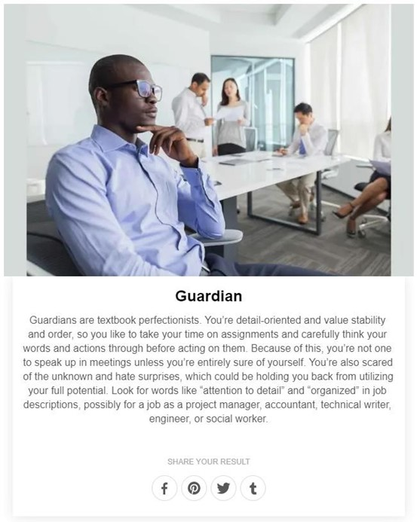

**Victor Heather**

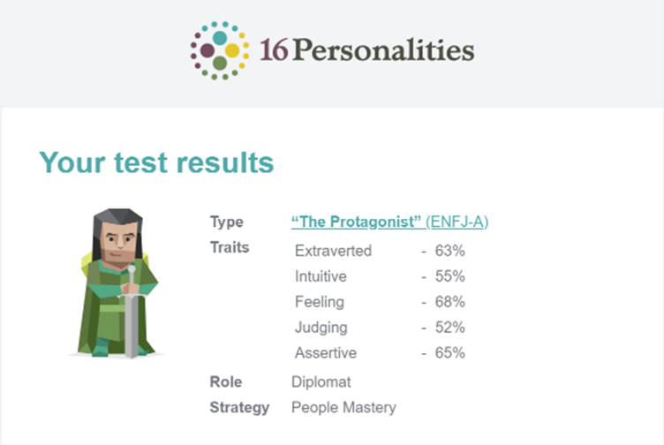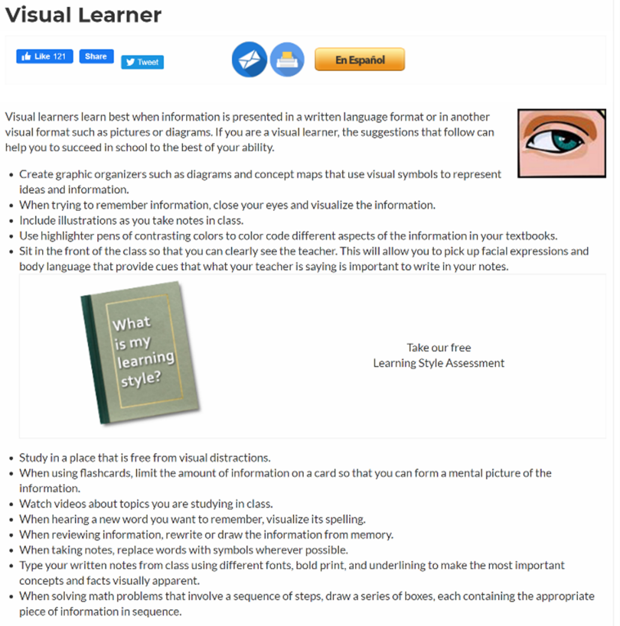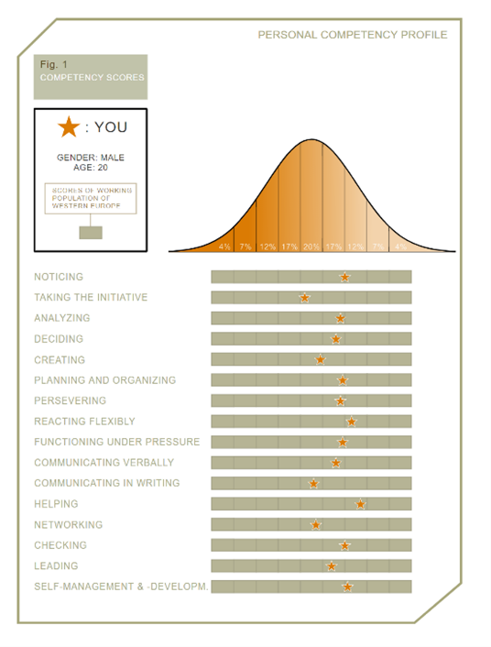

**Sahil Mann**